**PROTOCOL**to laboratory exercise

***Temperature Measurement***



|  |  |  |
| --- | --- | --- |
| Group / Class | Secretary | Signature |
| 5 / **4BHELS** | HOFSTÄTTER A. |  |
| Exercise- / Delivery date | Employee | Signature |
| 11. Nov. 2014  18. Nov. 2014 | ROTT M. |  |
| Teacher | Employee | Signature |
| Bochdansky |  |  |
| Grade | Employee | Signature |
|  |  |  |
| ***Temperature Measurement***  *NTC, PTC & Diode* | | |
| **Used Devices**   |  |  |  |  |  | | --- | --- | --- | --- | --- | | Nr. | Device | Manufactor | Type | Place Nr. | | 1. | Power Supply | Mc Voice | NG1620-BL | - | | 2. | Power Supply | Mc Voice | NG1620-BL | - | | 3. | Power Supply | Mc Voice | NG1620-BL | - |   **Used Programs**   |  |  |  | | --- | --- | --- | | Nr. | Name | Version | | 1. | Altium Designer | 13 | | | |

ÜBUNGS-/ABGABE-DATUM

Klasse /Gruppe

NOTE

LEHRER

# Table of Contents

1 Table of Contents 2

2 Tasks 3

3 Direct temperature measuring 3

3.1 Thermistors 4

3.1.1 General Information 4

3.1.2 NTC 4

3.1.2.1 Measurement setup 4

3.1.2.2 Measurement results 4

3.1.3 PTC 5

3.1.3.1 Measurement setup 5

3.1.3.2 Measurement results 5

3.2 Diode 5

3.2.1 Measurement setup 5

3.2.1.1 Measurement diagram 6

4 Evaluation circuit (PTC) 6

4.1 Measurement Setup 6

4.2 Measurement Results 7

4.2.1 Measurement table 7

4.2.2 Measurement diagram 7

4.3 Measurement Results (without saturation) 8

4.3.1 Measurement table 8

4.3.2 Measurement diagram 8

5 List of Figures 9

# Tasks

Task of this laboratory exercise was to measure the temperature in several ways with different temperature depending resistors.

To simulate a changing temperature a heating furnace was used. The temperature depending devices were placed into this furnace and connected through case mounted wire jacks to a breadboard.

The following ways were used to determine the temperature.

* NTC (decreasing resistance by increasing temperature)
* PTC (increasing resistance by increasing temperature)
* Diode (temperature dependent characteristic)

Therefore that a temperature change on a diode or a NTC were not directly shown in Ohm a very little and basic circuit with a resistor and a power supply was used.

After testing several temperature resistors an evaluation circuit was built to analyse a temperature shift. For this circuit an operational amplifier was used.

# Direct temperature measuring

To measure the temperature flow with an NTC or PTC a simple Ohmmeter was used.

A Negative Temperature Coefficient Thermistors (NTC) has as the name say a negative temperature coefficient. So by increased temperature the NTC-Resistor gets a lower resistance.

In addition to the NTC there is a Positive Temperature Coefficient Thermistors (PTC). These Thermistors increase their resistance value by increased temperature.

In the following table the measured values for NTC, PTC and Diode were shown.

|  |  |  |  |
| --- | --- | --- | --- |
| Temperatur (° C) | NTC (Ohm) | Diode (V) | PTC (Ohm) |
| 23 | 22,0 | 0,723 | 89,40 |
| 25 | 19,7 | 0,720 | 90,10 |
| 30 | 14,0 | 0,710 | 93,40 |
| 35 | 11,0 | 0,704 | 98,00 |
| 40 | 9,30 | 0,696 | 105,4 |
| 45 | 8,30 | 0,687 | 114,5 |
| 50 | 7,00 | 0,680 | 128,0 |
| 55 | 6,00 | 0,670 | 151,0 |
| 60 | 5,10 | 0,664 | 183,0 |
| 65 | 4,10 | 0,655 | 220,0 |
| 70 | 3,00 | 0,649 | 300,0 |
| 75 | 2,60 | 0,643 | 427,0 |
| 80 | 2,20 | 0,637 | 715,0 |
| 85 | 2,20 | 0,625 | 1240 |
| 90 | 2,00 | 0,615 | 2039 |
| 95 | 1,80 | 0,608 | 4194 |
| 100 | 1,50 | 0,598 | 7581 |

**Table 1.** - Measured Values (NTC, PTC & Diode)

## Thermistors

### General Information

A thermistor is a type of resistor whose resistance varies significantly with temperature, more so than in standard resistors. Thermistors are widely used as inrush current limiters, temperature sensors, self-resetting overcurrent protectors, and self-regulating heating elements.

Thermistors differ from resistance temperature detectors (RTDs) in that the material used in a thermistor is generally a ceramic or polymer, while RTDs use pure metals. The temperature response is also different; RTDs are useful over larger temperature ranges, while thermistors typically achieve a higher precision within a limited temperature range, typically −90 °C to 130 °C. In this laboratory exercise a thermistor was used.

The difference between PTC and NTC is that the PTC (Positive) increases his resistance by rising temperature and the NTC (Negative) decreases his resistance.

### NTC

#### Measurement setup

The NTC was located in the heating oven and connected with preinstalled wire jacks on the furnace to an ohmmeter. The resistance of the NTC was notated and analysed.

#### Measurement results

The following diagram shows the characteristic line by increasing temperature with the use of a NTC.

Figure 1. - NTC Characteristic

### PTC

#### Measurement setup

The NTC was located in the heating oven and connected with preinstalled wire jacks on the furnace to an ohmmeter. The resistance of the NTC was notated and analysed.

#### Measurement results

The following diagram shows the characteristic line by increasing temperature with the use of a PTC.

Figure 2. - PTC Characteristic

## Diode

### Measurement setup

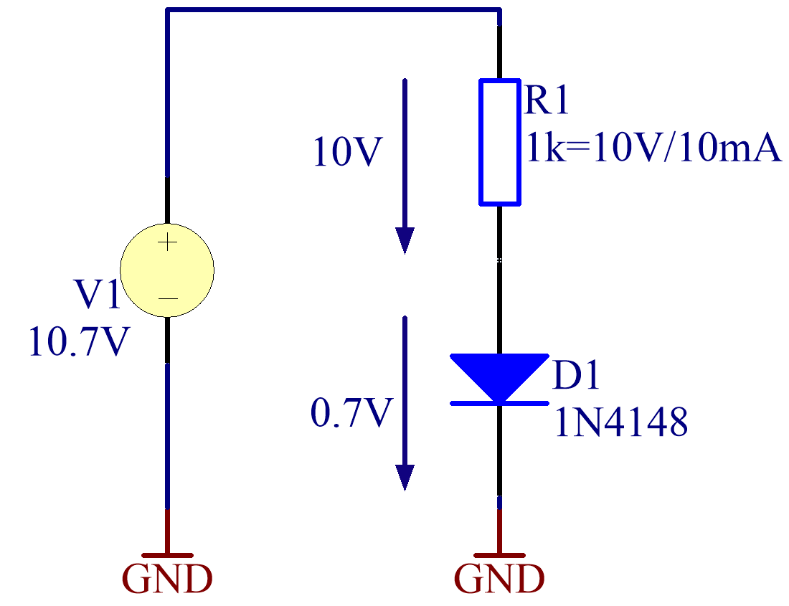Therefore the characteristic of a diode is temperature dependent. So it is possible to generate a temperature flow characteristic with the use of the following basic circuit.

A very simple circuit with a power supply and a serial resistor before the diode was used. To limit the maximum input current at the diode to 10 mA a resistor has been used.

Therefore the potential at the diode was 0.7 V the potential which lays on the resistor was so chosen that it was simple to calculate and realizable without resistor tolerance 10 V were chosen. So the power supply was set to 10.7 V.

Figure 3. - Basic circuit for Diode

With a 1 kΩ serial resistance to the diode, the current was successfully limited to a maximum of 10 mA.

Therefore no damage to the devices was guaranteed.

#### Measurement diagram

Figure 4. - Diode Characteristic

# Evaluation circuit (PTC)

## Measurement Setup

For the required operational amplifier the LM358 type was used. This type is usually a dual operational amplifier but only one OPV was in use. The task of this circuit was to generate increased voltage with an increased resistance.

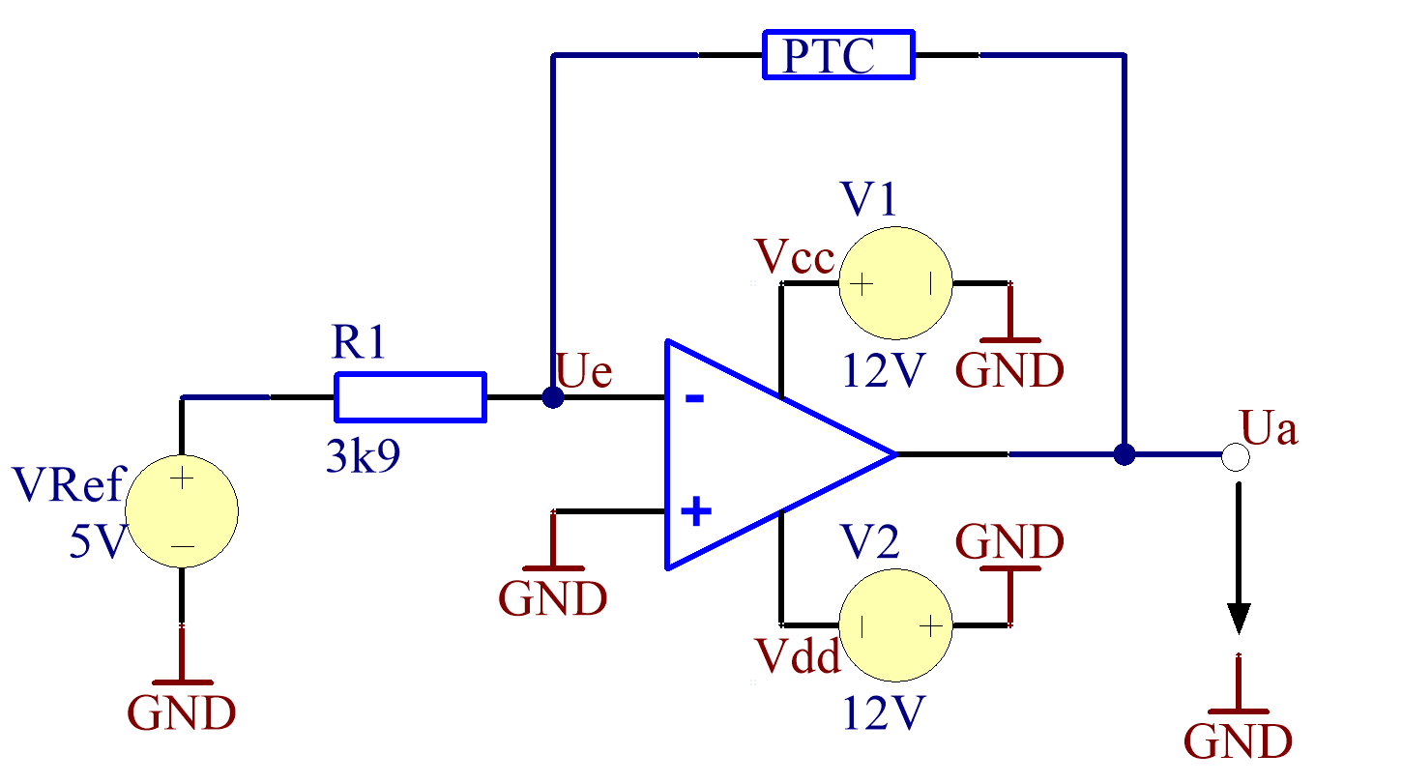

Figure 5. - OPV evaluation circuit for PTC

The following pins were used in this circuit.

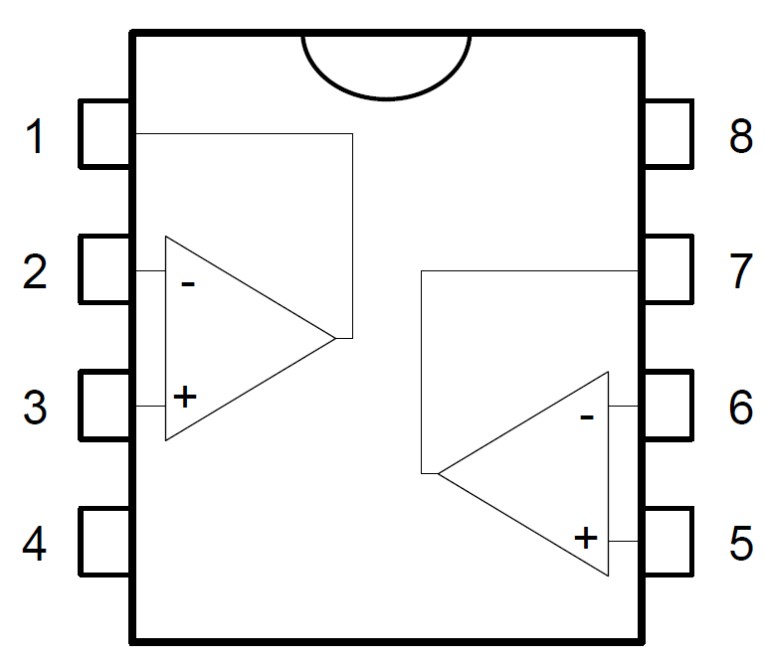

1 - Output (OPV 1)

3 - Inverting input (OPV 1)

3 - Non-inverting input (OPV 1)

4 - VCC-

8 - VCC+

The basic concept is a voltage divider in which one of the static resistors were replaced by the PTC.

Figure 6. - LM358 Pinning

So changed resistance trough a temperature change has an effect to the output voltage.

The operational amplifier was supplied by a symmetric ± 12 V voltage source.

## Measurement Results

Also in this task, as in all other, the temperature dependent device was stored into an heat furnace and connected through wire jacks to the breadboard which was located outside the heat oven.

### Measurement table

|  |  |
| --- | --- |
| Temperatur (° C) | OPV output Ua (V) |
| 23 | 2,470 |
| 25 | 2,500 |
| 30 | 2,500 |
| 35 | 2,609 |
| 40 | 2,828 |
| 45 | 3,109 |
| 50 | 3,507 |
| 55 | 4,108 |
| 60 | 5,000 |
| 65 | 6,047 |
| 70 | 7,280 |
| 75 | 8,340 |
| 80 | 9,300 |
| 85 | 9,830 |
| 90 | 10,29 |
| 95 | 10,62 |
| 100 | 10,82 |

Table 2. - Measured Values (Voltage – OPV output)

### Measurement diagram

Figure 7. - OPV (PTC) Characteristic

Thereby that the operational amplifier was provided with only ± 12 V and the calculated maximum output voltage for the highest possibly temperature was more than 12 V the circuit comes into the scope of a saturation.

In above diagram this is exactly how it looks like when the circuit comes up to saturation. An easy fix for this solution could be the increase of the supply voltage from ±12 V to ±16 V which is declared as the absolute maximum supply voltage according to the datasheet of the LM358.

## Measurement Results (without saturation)

As mentioned above the operational amplifier was supplied by ±16 V rather than ±12 the saturation was did not happen.

### Measurement table

|  |  |
| --- | --- |
| Temperatur (° C) | OPV output Ua (V) |
| 23 | 2,470 |
| 25 | 2,500 |
| 30 | 2,500 |
| 35 | 2,609 |
| 40 | 2,828 |
| 45 | 3,109 |
| 50 | 3,507 |
| 55 | 4,108 |
| 60 | 5,000 |
| 65 | 6,047 |
| 70 | 7,280 |
| 75 | 8,340 |
| 80 | 9,300 |
| 85 | 9,830 |
| 90 | 10,29 |
| 95 | 10,62 |

Table 3. - Measured Values (Voltage – OPV output)

### Measurement diagram

Figure 8. - OPV (PTC) Characteristic – without saturation

In the last (correct) setup (supply voltage = ±16 V) the output voltage characteristic was analysed and measured correctly and a diagram without saturation was generated.

# List of Figures

Figure 1. - NTC Characteristic 4

Figure 2. - PTC Characteristic 5

Figure 3. - Basic circuit for Diode 5

Figure 4. - Diode Characteristic 6

Figure 5. - OPV evaluation circuit for PTC 6

Figure 6. - LM358 Pinning 6

Figure 7. - OPV (PTC) Characteristic 7

Figure 8. - OPV (PTC) Characteristic – without saturation 8